**NAME**: - Jaydeep Solanki

**ROLL NO**: - 22ECG060 | 22BEC059

**COURSE CODE**: - 1CS501

**SUBJECT**: - COMPUTER PROGRAMMING

**PRACTICAL NO 1:**  Demonstration of CodeBlocks IDE, Writing and compiling a simple C  program

1. Demonstration of CodeBlocks IDE. Make use of CodeBlocks to write and compile a simple C program (“Hello World”).

**Code :**

#include <stdio.h>

int main() {

printf("Hello world!\n");

return 0;

}

**Output:**

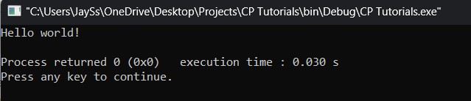

1. Illustrate the use of scanf and printf function to read and display values of different types of variables, address of a variable in C language.

1. To scan and print values of different types of variables

**Code:**

#include <stdio.h>

int main() {

int a1;

float a2;

char a3[100];

double a4;

printf("Enter integer number :");

scanf("%d", &a1);

printf("\nEnter floating number :");

scanf("%f", &a2);

printf("\nEnter a character :");

scanf("%s", &a3);

printf("\nEnter double number :");

scanf("%lf", &a4);

printf(" \nYour \n1. Integer : %d\n2. Floating : %f\n3. Character : %s\n4.Double : %lf\n",a1, a2, a3, a4);

return 0;

}

**Output:**

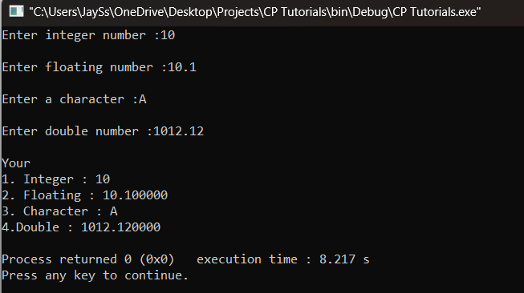

2. To print address of a variable.

**Code:**

#include <stdio.h>

int main()

{

int c;

printf("C is located at : %p", &c);

return 0;

}

**Output:**

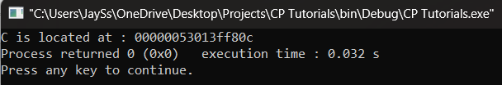

3. To demonstrate different escape sequence.

**Code:**

#include <stdio.h>

int main()

{

printf("This is a tab: \t and this is a newline: \n");

printf("This is a single quote: \' and this is a double quote: \"");

printf("This is a backslash: \\ and this is a question mark: \?");

return 0;

}

**Output:**

